Department of Computer Science and Engineering
Assignment Questions
Course Code & Name : DSA0101 - Object Oriented Programming with C++
Assignment Title: | Smart Civic Complaint and Public Safety Response System using C++
Course Outcome(s) – CO: | CO2: Design C++ programs by applying functions and object-oriented concepts such as classes, objects, access specifiers, member functions, static members, and arrays of objects to solve real-world programming problems.  CO3: Construct C++ programs using constructors, destructors, and operator overloading mechanisms to control object creation, destruction, and operator behaviour.  CO4: Analyse and implement C++ applications using inheritance, types of inheritance, virtual base classes, abstract classes, pointers, and polymorphism to design reusable and extensible programs.
Bloom’s Taxonomy Level | L3 – Apply; L4 – Analyse
SDG Mapping (SDG 1-17) | SDG 9 – Industry, Innovation and Infrastructure; SDG 11 – Sustainable Cities and Communities; SDG 16 – Peace, Justice and Strong Institutions
Problem Statement : Design, implement, and evaluate a menu-driven, object-oriented C++ application for a Smart Civic Complaint and Public Safety Response System that helps citizens report common urban problems such as potholes, streetlight failures, garbage accumulation, water leakage, unsafe public spaces, and other civic issues. The system shall register citizens and complaints, classify complaints based on type and urgency, assign complaints to appropriate municipal response teams, update complaint status, calculate priority scores, compare complaints, track team workload, and generate a civic response report. The core entities shall be represented using appropriate classes and objects with private/protected data members, public member functions, and suitable access specifiers. Functions shall be used to modularize citizen registration, complaint registration, classification, priority evaluation, team assignment, status updates, score calculation, and report generation. Static members shall maintain shared information such as the total number of complaints, active complaints, or available response teams, while arrays of objects shall be used to manage multiple citizens, complaints, and response teams.
The application must demonstrate default, parameterized, and copy constructors for controlled object creation, destructors for releasing dynamically allocated resources and finalizing complaint records, and at least two meaningful operator overloads (for example, comparing complaint priorities and combining workload/capacity values or formatting reports). A reusable inheritance hierarchy shall be designed using suitable forms of inheritance; a virtual base class shall be used where a diamond/multiple-inheritance situation occurs, and an abstract base class shall define common response-team behaviour. Pointers, base-class pointers, virtual functions, and runtime polymorphism shall be used so that different municipal teams such as sanitation, road maintenance, electrical, water, or public-safety teams can be handled dynamically. The design should be extensible, so that a new complaint category or response-team type can be added with minimal changes to the existing system.
Assessment Rubrics
Criteria (CO Mapping) | Max Marks | Excellent | Good | Satisfactory | Needs Improvement
Requirement Understanding & System Design | (CO2/CO3/CO4) | 10 | Clearly identifies citizens, complaints, civic categories, response teams, workflow, constraints, and relationships; design directly supports all stated CO2/CO3/CO4 requirements. | Identifies most civic entities and workflow with minor omissions; design supports most requirements. | Basic complaint-handling workflow is identified, but relationships or requirements are incomplete. | Requirements are misunderstood; system design is fragmented or does not address the stated civic problem.
Classes, Objects, Functions, Static Members & Arrays of Objects | (CO2) | 15 | Well-designed classes and objects use suitable access specifiers and cohesive member functions; static members correctly maintain shared data; arrays of objects efficiently manage multiple entities. | Classes, functions, static members, and object arrays are implemented correctly with minor design or logical issues. | Basic classes/functions are present, but static members or arrays of objects are underused or partially correct. | Classes/functions are poorly designed; static members and/or arrays of objects are missing or non-functional.
Constructors & Destructors | (CO3) | 15 | Default, parameterized, and copy constructors are correctly implemented and meaningfully used; destructors safely finalize cases and release dynamic resources. | Most constructor types and destructor logic are correct, with minor implementation issues. | Some constructor types are implemented; destructor or resource-release logic is incomplete. | Constructors/destructors are missing, incorrect, or cause resource-management errors.
Operator Overloading | (CO3) | 15 | At least two meaningful operator overloads are correctly implemented and improve comparison, capacity handling, or report generation with clear semantics. | At least two overloads are implemented with minor logical or semantic issues. | Only one useful overload or partially correct overloads are implemented. | Operator overloading is absent, inappropriate, or non-functional.
Inheritance, Virtual Base Class & Abstract Class | (CO4) | 15 | Uses appropriate inheritance types; virtual base class correctly resolves shared-base ambiguity; abstract class/pure virtual functions provide a strong reusable hierarchy. | Inheritance and virtual base/abstract class concepts are correctly implemented with minor design limitations. | Basic inheritance is present, but virtual base or abstract-class usage is incomplete or superficial. | No meaningful inheritance hierarchy; virtual base and abstract-class requirements are missing or incorrect.
Pointers & Runtime Polymorphism | (CO4) | 15 | Uses pointers / base-class pointers safely; virtual functions enable runtime polymorphism across resource types; dynamic behaviour is extensible. | Pointers and virtual functions are implemented correctly with minor edge-case issues. | Pointers or polymorphism are used, but overriding/dynamic dispatch is limited or inconsistent. | Pointer usage is unsafe or runtime polymorphism is absent/non-functional.
Menu-Driven Functionality, Correctness & Report Generation | (CO2/CO3/CO4) | 5 | Citizen/complaint registration, team assignment, status updates, priority comparison, workload tracking, and report generation work correctly end-to-end through a clear menu-driven interface. | Most features work correctly; minor bugs occur in edge cases, status updates, or report formatting. | Core features work, but important functions such as team assignment, priority comparison, or reporting are incomplete/buggy. | Program is unreliable or major complaint-management features are missing/non-functional.
Reflection: Design Decisions, Innovation & Learning Outcomes | (CO2/CO3/CO4) | 10 | Provides thoughtful justification of design choices, explains how CO2/CO3/CO4 concepts solved the civic problem, discusses innovation, challenges, and learning with specific evidence. | Provides reasonable design justification and discusses concepts, challenges, and learning with some detail. | Reflection is present but generic; limited connection to civic design decisions or COs. | No genuine reflection, or content does not connect the implementation to CO2/CO3/CO4 learning.

Deliverables:
- Pseudo code
START

DECLARE maximum citizens = 50
DECLARE maximum complaints = 100

CREATE Citizen class
PRIVATE:
citizenId
name
phone
address

PUBLIC:
Default Constructor
Parameterized Constructor
Copy Constructor
getId()
getName()
display()
Destructor
END CLASS

CREATE Complaint class
PRIVATE:
complaintId
citizenId
category
description
urgency
priorityScore
status
assignedTeam

STATIC:
totalComplaints
activeComplaints

PUBLIC:
Default Constructor
Parameterized Constructor
Copy Constructor
calculatePriority()
get complaint details
assignTeam()
updateStatus()
overload > operator to compare priority
overload < operator to compare priority
display()
Destructor
END CLASS

CREATE MunicipalResource class
PROTECTED:
resourceId
resourceName

PUBLIC:
Constructor
displayResource()
Virtual Destructor
END CLASS

CREATE ABSTRACT ResponseTeam class
PROTECTED:
teamId
teamName
workload
capacity

STATIC:
availableTeams

PUBLIC:
Default Constructor
Parameterized Constructor

DECLARE PURE VIRTUAL FUNCTION:
respondToComplaint()

DECLARE VIRTUAL FUNCTION:
getSpecialization()

displayTeam()

overload + operator
Destructor
END CLASS

CREATE FieldOperations class
VIRTUALLY INHERIT MunicipalResource
END CLASS

CREATE EmergencyOperations class
VIRTUALLY INHERIT MunicipalResource
END CLASS

CREATE DIFFERENT RESPONSE TEAMS

SanitationTeam inherits ResponseTeam

RoadMaintenanceTeam inherits ResponseTeam

ElectricalTeam inherits ResponseTeam

WaterTeam inherits ResponseTeam

PublicSafetyTeam inherits:
ResponseTeam
FieldOperations
EmergencyOperations

END

CREATE ARRAY citizens[MAX_CITIZENS]
CREATE ARRAY complaints[MAX_COMPLAINTS]

SET citizenCount = 0
SET complaintCount = 0

FUNCTION RegisterCitizen()

IF citizenCount is equal to MAX_CITIZENS
DISPLAY "Citizen storage is full"
RETURN
END IF

INPUT citizen ID
INPUT citizen name
INPUT phone number
INPUT address

CREATE Citizen object

STORE citizen in citizens array

INCREMENT citizenCount

DISPLAY "Citizen Registered Successfully"

END FUNCTION

FUNCTION CitizenExists(citizenId)

FOR every registered citizen

IF citizen ID matches input ID
RETURN TRUE
END IF

END FOR

RETURN FALSE

END FUNCTION

FUNCTION RegisterComplaint()

IF complaintCount is equal to MAX_COMPLAINTS
DISPLAY "Complaint storage is full"
RETURN
END IF

INPUT complaint ID
INPUT citizen ID

IF citizen does not exist
DISPLAY "Register citizen first"
RETURN
END IF

DISPLAY complaint categories

INPUT category choice

ASSIGN category according to choice

INPUT complaint description

INPUT urgency level

CALCULATE priority score

CREATE Complaint object

STORE complaint in complaints array

INCREMENT complaintCount

DISPLAY "Complaint Registered Successfully"

END FUNCTION

FUNCTION CalculatePriority()

ASSIGN category score according to complaint category

priorityScore =
urgency × 10 + categoryScore

RETURN priorityScore

END FUNCTION

FUNCTION DisplayComplaints()

IF no complaints exist
DISPLAY "No complaints registered"
RETURN
END IF

FOR every complaint

DISPLAY complaint details

END FOR

END FUNCTION

FUNCTION FindComplaint(complaintId)

FOR every complaint

IF complaint ID matches
RETURN complaint index
END IF

END FOR

RETURN -1

END FUNCTION

FUNCTION AssignComplaint(ResponseTeam pointers)

INPUT complaint ID

FIND complaint

IF complaint does not exist
DISPLAY "Complaint not found"
RETURN
END IF

GET complaint category

IF category is Garbage
SELECT SanitationTeam

ELSE IF category is Pothole
SELECT RoadMaintenanceTeam

ELSE IF category is Streetlight
SELECT ElectricalTeam

ELSE IF category is Water Leakage
SELECT WaterTeam

ELSE IF category is Unsafe Public Space
SELECT PublicSafetyTeam

ELSE
DISPLAY "No suitable response team available"
RETURN
END IF

CALL respondToComplaint()

ASSIGN selected team to complaint

INCREMENT team workload

END FUNCTION

FUNCTION UpdateComplaintStatus()

INPUT complaint ID

FIND complaint

IF complaint does not exist
DISPLAY "Complaint not found"
RETURN
END IF

DISPLAY status options:
Pending
Assigned
In Progress
Resolved

INPUT new status

UPDATE complaint status

IF complaint becomes Resolved
DECREMENT activeComplaints
END IF

DISPLAY "Status Updated Successfully"

END FUNCTION

FUNCTION CompareComplaints()

INPUT first complaint ID
INPUT second complaint ID

FIND both complaints

IF either complaint does not exist
DISPLAY "Complaint not found"
RETURN
END IF

USE overloaded > operator

IF first complaint priority is greater
DISPLAY first complaint has higher priority

ELSE IF second complaint priority is greater
DISPLAY second complaint has higher priority

ELSE
DISPLAY both complaints have equal priority
END IF

END FUNCTION

FUNCTION DisplayTeamWorkload()

FOR every response team

DISPLAY:
Team ID
Team Name
Specialization
Workload
Capacity

END FOR

USE overloaded + operator

CALCULATE combined workload
of two response teams

DISPLAY combined workload

END FUNCTION

FUNCTION GenerateReport()

SET pending = 0
SET assigned = 0
SET inProgress = 0
SET resolved = 0

FOR every complaint

CHECK complaint status

INCREMENT corresponding status count

END FOR

DISPLAY:
Total Citizens
Total Complaints
Active Complaints
Resolved Complaints
Pending Complaints
Assigned Complaints
In Progress Complaints
Available Response Teams

END FUNCTION

MAIN FUNCTION

CREATE:
SanitationTeam object
RoadMaintenanceTeam object
ElectricalTeam object
WaterTeam object
PublicSafetyTeam object

CREATE array of ResponseTeam pointers

STORE addresses of all teams
in ResponseTeam pointer array

REPEAT

DISPLAY MENU:

1. Register Citizen
2. Display Citizens
3. Register Complaint
4. Display Complaints
5. Assign Complaint to Response Team
6. Update Complaint Status
7. Compare Complaint Priorities
8. Display Team Workload
9. Generate Civic Response Report
0. Exit

INPUT user choice

SWITCH choice

CASE 1:
RegisterCitizen()

CASE 2:
DisplayCitizens()

CASE 3:
RegisterComplaint()

CASE 4:
DisplayComplaints()

CASE 5:
AssignComplaint()

CASE 6:
UpdateComplaintStatus()

CASE 7:
CompareComplaints()

CASE 8:
DisplayTeamWorkload()

CASE 9:
GenerateReport()

CASE 0:
DISPLAY "Thank you for using the system"

DEFAULT:
DISPLAY "Invalid Choice"

END SWITCH

UNTIL user choice is 0

END

- C++ Implementation Test Cases & Results
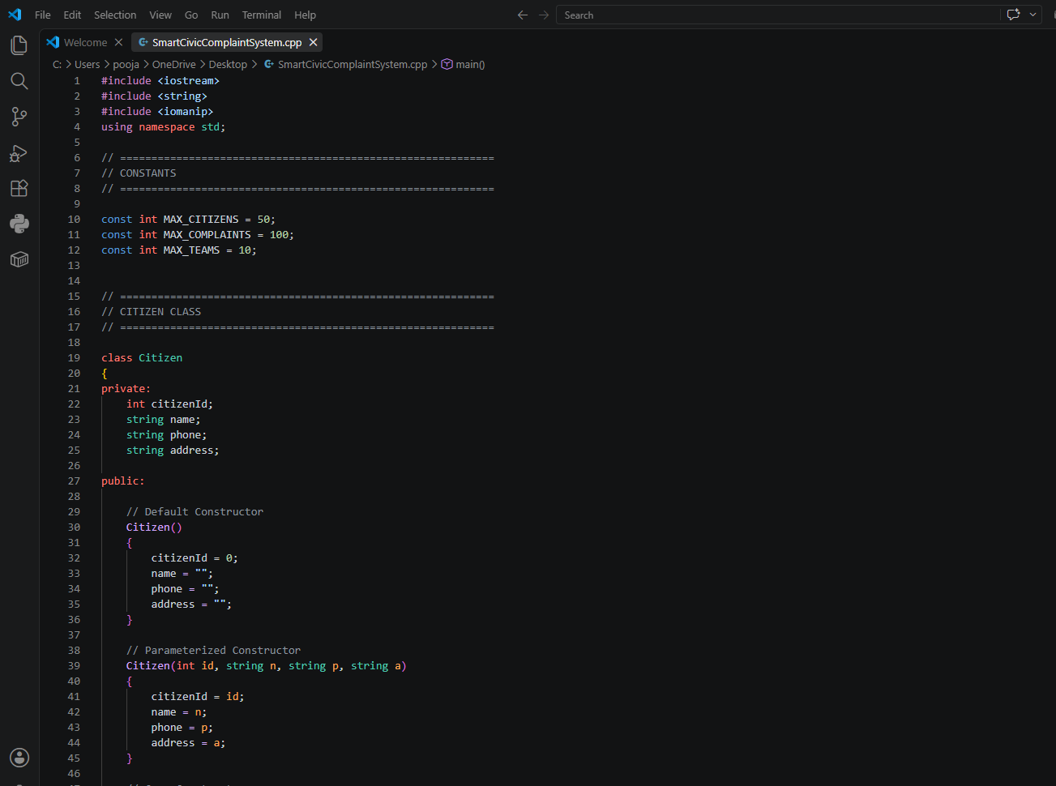
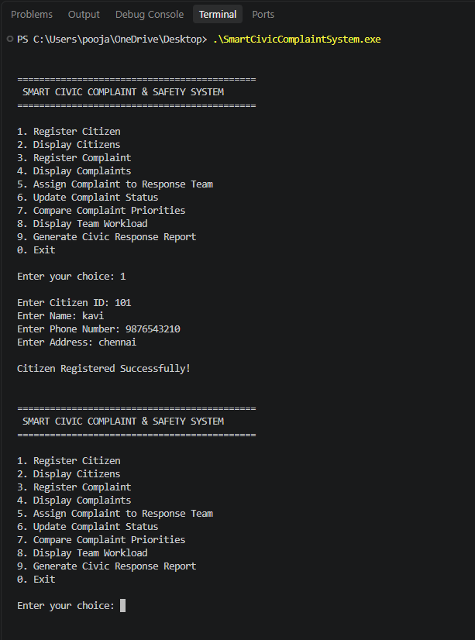

- Github Upload

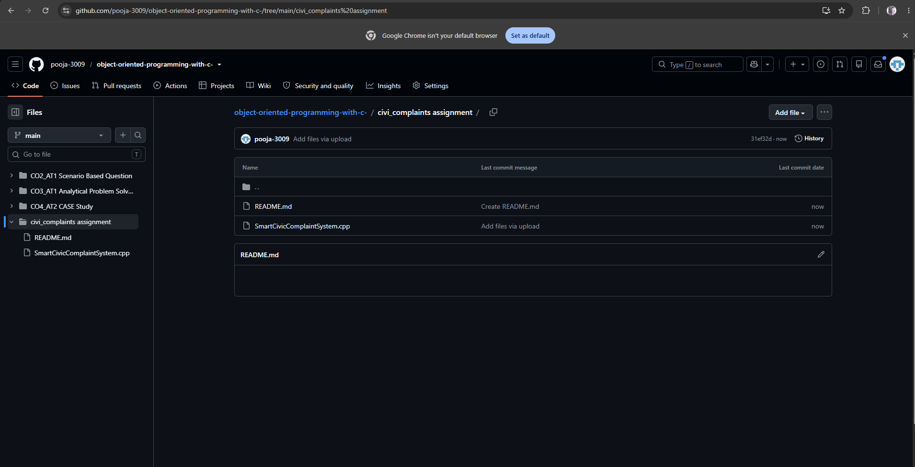
https://github.com/pooja-3009/object-oriented-programming-with-c-/tree/main/civi_complaints%20assignment

